**In order to collect questions that may be asked, we created this document. Please write the answer in the shortest possible way(Show when you are asked this question, how do you answer). Please follow the format.**

**1.What is Weak program?**

**2.** **Let S be a program and F be a problem, how can we say S is totally correct with respect to F(or solves the problem F)?**

For any state in the domain of the problem, it is guaranteed that the program terminates faultlessly starting its execution from the given state

For any state in the domain of the problem, starting its execution there, the program ends up in “good” states (that are assigned to the given state by the problem)

The state given by the problem can be perfectly executed by S(terminates very well without errors or endless),and the program can end up on the state which is assigned to the given state by the problem.

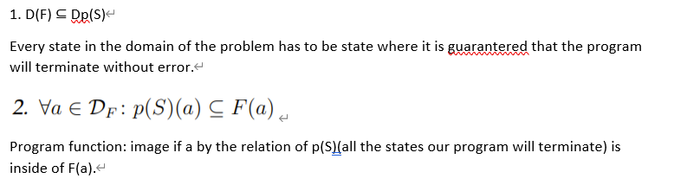

When F1 and F2 is composition

We can say

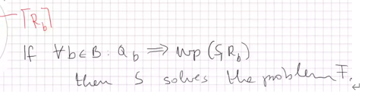

**3. How can we say S1 and S2 programs are equivalent?**

When Program function S1 equal Program function S2.

**4.Let S be a program and F be a problem. How can we say that program S is partially**

**correct with respect to F?**

**5.What is set?**

A set is a collection of objects, which are called the elements of the set. We cannot have the same elements in a set.

**6.What is relations?**

A relation can be considered as a mapping from the set A to B.

Definition: Let A and B be arbitrary not empty sets. Any subset R (including the empty set) of A × B is called a relation.

**7.How can a relation be called deterministic? What is function?**

For any element in D (R), there is only one definite element corresponding to it.This relationship is also called “function”

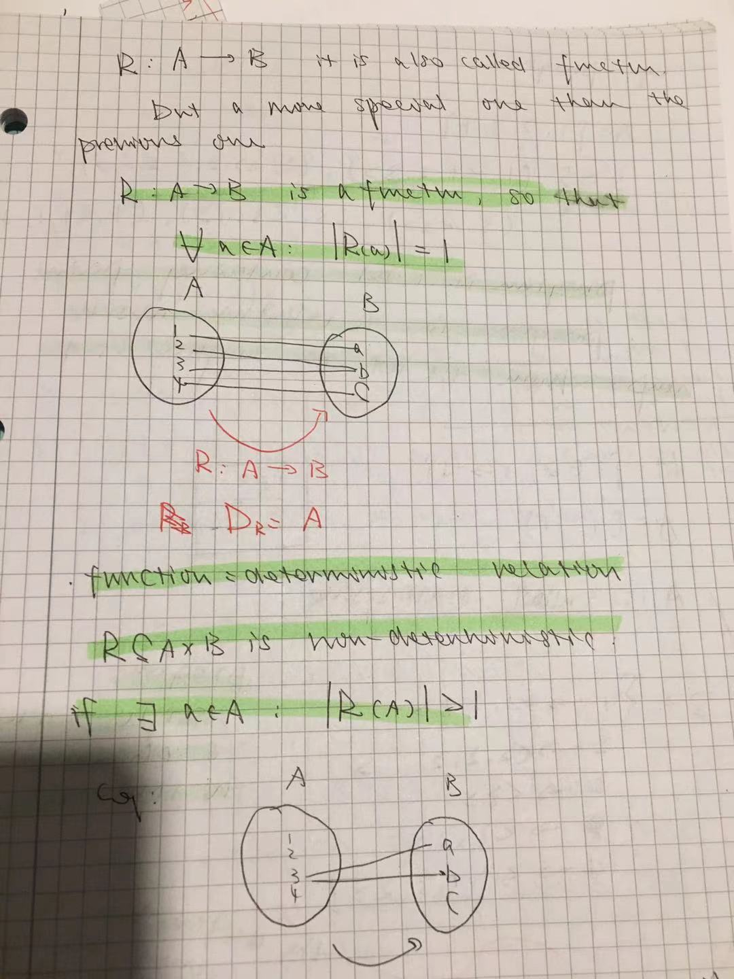

**8.What is Problem?**

Let A by an arbitrary statespace. Any F ⊆ A × A relation is called problem. Problem is a mapping from the statespace to the same statespace.

A problem is a relation which assigns a state to state

**9.What is Program?**

We defined the program as a relation that maps from the statespace A to the set of finite and infinite sequences include fail status.

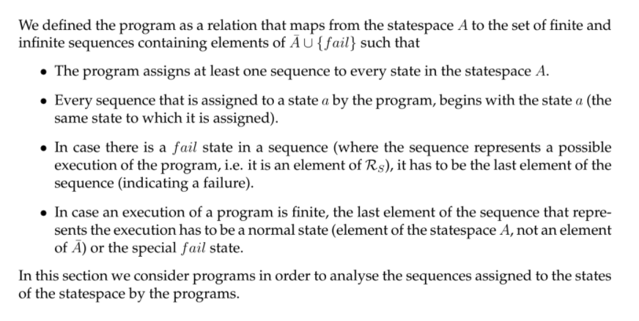

**10.What is Weak program function?**

For any state a, the weak program function p ̃(S) gives all the states where the program S can terminate starting its execution from state a.Including fail state. We can not guarantee our program will terminate at all.

**11.What is Program function?**

For any state a, the program function p(S) gives all the states where the program S can terminate starting its execution from state a, but p(S) is applicable only in states from where there are no faulty or endless executions the program can produce.(exclude fail state and endless state).

We consider all possible original states(check all states from statespace), which can not be assigned to infinite sequence or failed state, and if the state not be assigned to infinite sequence and failed state, we write all pairs original stats with its end states.

**12.Determine the sequence (S1; S2)(What is sequence)?**

Briefly saying we get the sequence of two programs by executing the two porgrams after each other: first we execute S1, then we execute S2. Program S1 can assign three different kind of sequences to an arbitrary state a: an infinite sequence, a finite sequence ending in the fail state, or a finite sequence ending in a state of A. In the first two cases program S2 cannot do anything: in case program S1 assigned an infinite sequence to state a or a finite sequence with the last element fail, then the sequence (S1; S2) assigns the same sequence to the given state a.

**13.Determine the selection (π1:S1, π2:S2)(What is selection)?**

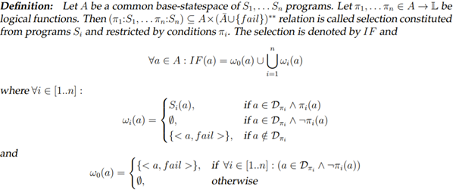

Definition: here we have 3 cases for wi: first one: if the “a” is in the domain of branch and the branch is true then we execute following program according to that condition. Second one: if “a” is in the domain of the branch but it is not true then we write nothing. Third one if “a” is not in the domain of branch then we write fail state.

There is also possible special case when we write nothing for “a”. It means it is in the domain of all branches but none of them true. Then we write also fail state.

**14.Determine the loop (π, S0)(What is loop)?**

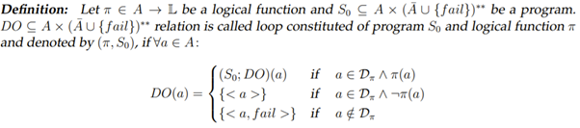

**15.What is “implies” relation?**

Lets Q, R be any logical functions. The true sets Q belong to true sets R holds( true sets Q is a subset of true sets R), then we say Q implies R.

**16.What is Weakest precondition?**

It is logical function which maps to statespace to the set of logical values. Wp(S,R) : A -> L

The weakest precondition holds for a state a, if it is guaranteed that the program S terminates without failure in case it start its execution from state a and every execution of S starting from a ends in states where R holds.

Its can make sure something before the execution of the program.Program will terminate without error and in states where the given condition is true.

If we have a state, it can be assigned to true by weekset precondition then we have two conditions. 1st: is like it can not be assigned by program S to a infinite sequence or failed end state.2st: if its not be assigned to infinite sequence or failed state,and all end states(now its good state) according to this state must can be assigned to true by R.

**17.What is parameter space?**

We say that set B is a parameter space of problem F ⊆ A × A, if there exist a

relation F1 ⊆ A × B and relation F2 ⊆ B × A, such that F = F2 bind F1 holds.

We want to express problem F use composition F2 bind F1.

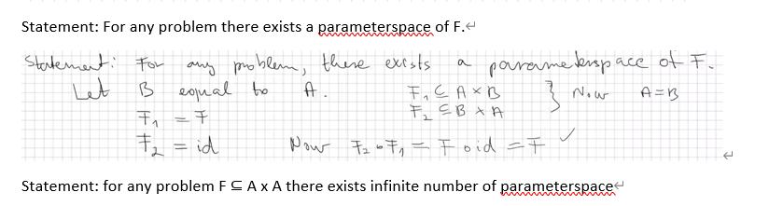

**18.What is inverse relation?**

Let A and B not empty arbitrary sets and R ⊆ A × B be any relation.the inverse of R maps from set B to set A, that only contains the pair (b, a) ∈B × A, if (a, b) ∈ R.

**19.What is statespace?**

Statespace is the set of all possible states.

**20.What is state?**

Collection of data, and the data is labelled by the variables.

State is data. Like A=[1,2,3,4] , A is statespace and 1 is one of state.

**21.What is Await statement?**

When the program executes to await, wait for B to become true, and continue to execute the part of S in await,which is indivisible. If multiple processes are waiting for B to become true, then one of them is allowed to pass when B becomes true.

**22.What is Deadlock?**

When there are more than two processes, both parties are waiting for the other to stop running in order to obtain system resources, but no one exits early, it is called a deadlock.

A,B are two processes, both of them are running. A can terminate when B has terminated, and B can terminate when A has terminated. Both of them are waiting for each other to be terminated .So the program can never stop, it is called deadlock.

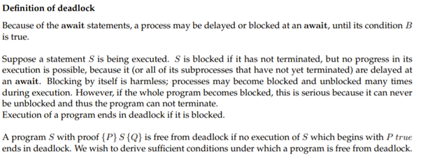

**23.What is interference freedom?**

Interference freedom means that none of the statements in the parallel block invalidates the proof outline assertions of any other component.

**interference freedom we are checking programs inside of parbegin statement. the programs should not interfere for each other's total correctness**.

**24.What is loop invariant?**

Loop invariant is a logical function, During the execution of the loop body, its value will always true.

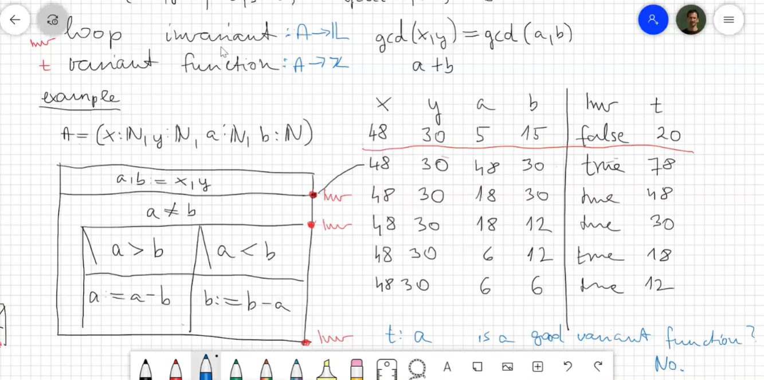

**25.What is loop Variant?**

Loop variant is a function which return integer value, During the execution of the loop body, its value will keep decreasing.



**t = a is not a good variant function here.**

**26.How can we verify deadlock freedom?**

The formula is false, deadlock-free.

**27.What is the condition for total correct (How can we say a program is total correct) ?**

The precondition of the program can implies the weakest precondition of the program and the postcondition.

**28.What are the elementary programs?**

Abort



Skip



Assignment: There can be multiple assignment(x,y := y,x), value selection(x: ∈ in {x-1, x-2} selection from different numbers to one variable).

**29.What is logical function:**

Assign a state to a true set.

**30.The properties of weakest precondition.**

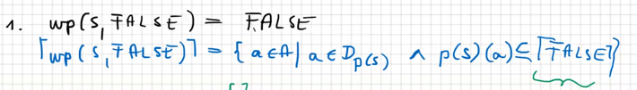

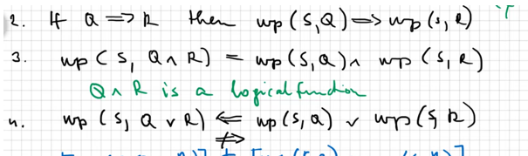

**31. How can we say a program is interfere-freedom(the condition of interfere-freedom)?**

**We dont want program to interfere the results of each other**

**1.Postcondition is preserved**

**2.Precondition is preserved**

**3.variant cannot be greater**

**32.What is atomic programs?**

Atomic means it is non-interruptible. We mostly consider assignment as a atomic program.

**33. What is multiprogram model?**

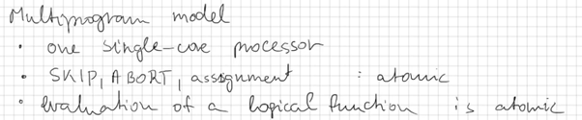

**34. What is critical statement?**

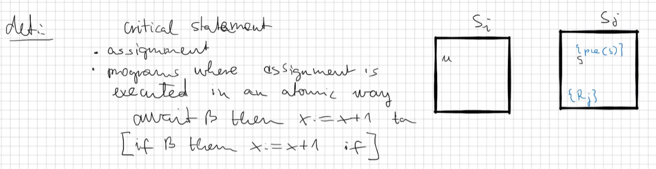

**35. Explain Theorem of specification**

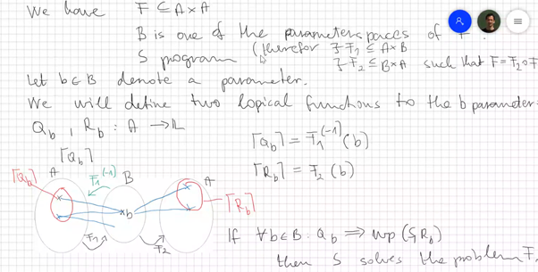

i said if we have problem F which is relation from statespace to statespace. and we have B parameterspace in F, then program S. for all paramter b in parameterspace B if Qb implies wp (S, Rb) then S solves the problem F

Its easier for us to check if S can solve F problem or not

**-------------------------------------------------------------------------------------------------------------------------------**

**H* means its a finite set and every element in H* come from Set H**

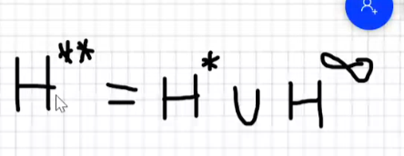

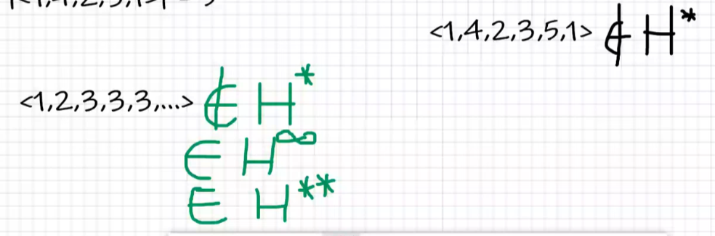

**When R is a deterministic relation (function ) we can use:**



**Multiple assignment**

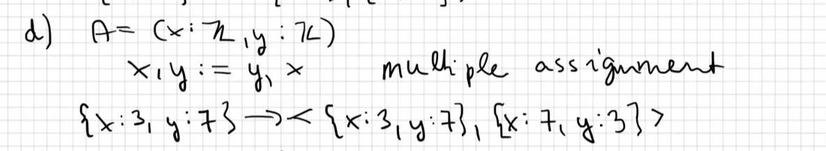

**Value selection**

